SOCIAL MEDIA SENTIMENT ANALYSIS
Alli Sunvith Reddy, Atla Tarun Kumar, Annepally Sanjay, Rohith
B. Tech Computer Science- Data Science AI & ML with upgrad, Lovely Professional University
Phagwara, Punjab- 144411.
^{Abhinaya Anand}

Abstract— The "Social Media Text Analysis" app for Reddit utilizes advanced NLP and machine learning to enhance interactions, understanding emotions and generating tailored responses for a personalized experience.
Keywords— NLP, Emotions, Reddit, Visual, Interactions
- Introduction
The "Social Media Text Analysis" project aims to extract insights from Reddit data using advanced NLP techniques. It focuses on sentiment analysis, text auto-generation, and auto-correction within social media interactions.
- Methodology
The project focused on obtaining a comprehensive dataset from Reddit to represent varied user interactions and sentiments across social media platforms.

The process involved several steps, ensuring both breadth and depth in the data gathered:

i. Platform Selection: Reddit was chosen initially for its vast user base and diverse content.

ii. API Utilization: We used the Reddit API to fetch data programmatically, capturing various data points.

iii. Real-time Data Acquisition: We implemented real-time collection to capture evolving trends and discussions.

iv. Data Pre-processing: Extensive pre-processing included cleaning, normalization, and categorization.

v. Ethical Considerations: We adhered to ethical guidelines, ensuring user privacy and anonymity.

vi. Data Storage and Management: Robust storage solutions were used for easy access and analysis.

vii. Time Series Analysis: Time series graphs were employed to understand trends over time.

viii. Sentiment Distribution: Visualizations like pie charts and bar graphs depicted sentiment distribution across posts.

ix. Word Clouds: Word clouds highlighted prevalent themes and subjects within the text data.

x. Correlation Heatmaps: Heatmaps explored correlations between different variables.

xi. Interactive Dashboards: Dashboards enabled dynamic exploration of the data.

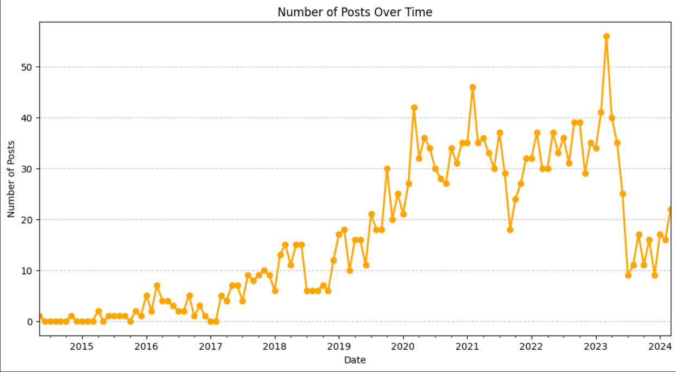
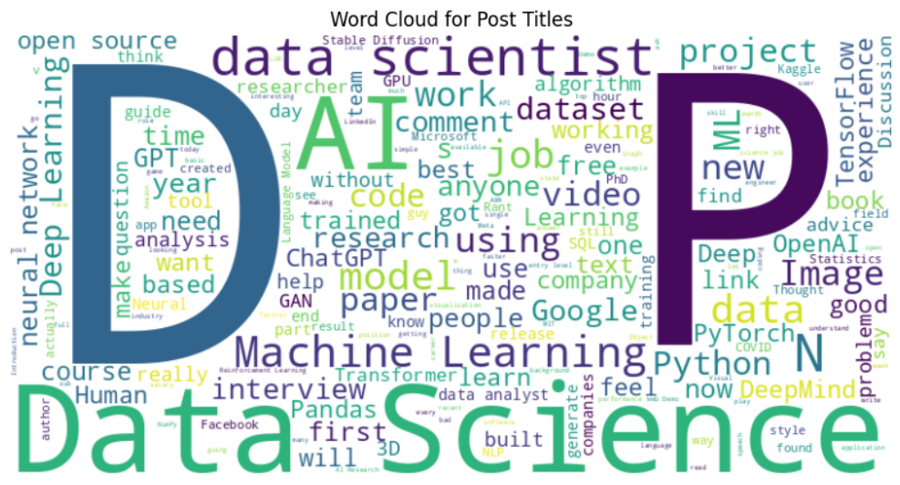

III. AUTO-GENERARTION
A) Content Summarization
Importance and Implementation: In the vast sea of social media data, extracting concise summaries becomes paramount. Utilizing NLP techniques, our project implements an auto-summarization feature, powered by algorithms like BERT and GPT through the Gemini API. This AI-driven component generates brief, coherent summaries, enhancing user interface and saving time for stakeholders needing to make informed decisions.
Technical Challenges and Solutions: Developing an effective summarization tool posed challenges, including maintaining context and handling diverse languages. We overcame these by training models on a broad dataset and ensuring continuous learning and updates.

B) Automated Insights
Algorithmic Analysis for Pattern Recognition: Leveraging machine learning algorithms, our project auto-generates insights by identifying patterns, trends, and anomalies in the data, including sentiment analysis, topic modeling, and trend analysis, crucial for strategic decision-making.
Application in Strategic Decision-Making: Automated insights provide a foundation for strategic decision-making, enabling businesses to align strategies with public opinion and interest. Overcoming Analytical Limitations: The complexity and volume of social media data often make manual analysis impractical. Our automated insights system addresses this by efficiently processing large datasets to highlight relevant trends and anomalies. This enables users to focus on strategic analysis rather than data processing, optimizing resource allocation.

C) Multilingual Support
Breaking Language Barriers: Our project breaks language barriers using advanced NLP techniques and the Gemini API for real-time translation and sentiment analysis, enhancing inclusivity and global reach.
Technical Integration and Challenges: Implementing multilingual support involved addressing challenges such as dialect variations and contextual nuances. Our approach includes training the system on diverse languages and dialects, ensuring accurate analysis and insights across different languages.

IV. AUTO-CORRECTION
Auto-correction in the context of social media text analysis is not just a feature but a necessity. Given the informal and often unstructured nature of social media communication, auto-correction ensures clarity, accuracy, and understandability of the data being analyzed. This aspect of the project can be elaborated across three main components: A) Error Detection and Correction, B) Contextual Understanding, and C) User Interaction Enhancement.

A) Error Detection and Correction
Challenges in Slang and Abbreviation Correction: Social media text is rife with slang, abbreviations, and non-standard expressions. Addressing this challenge required creating a dynamic, constantly evolving database of slang and abbreviations used in social media contexts. Integrating this database into our correction algorithms allows for a more nuanced and comprehensive understanding and correction of social media text.
Importance in Data Cleaning: In the realm of data analysis, the cleanliness of the data directly impacts the quality of insights derived. By implementing an auto-correction mechanism, we significantly improve the data quality by rectifying inaccuracies at the source, thereby ensuring that the analysis performed on this data is based on accurate and reliable information.
Implementation of Advanced Algorithms: The foundation of our auto-correction feature lies in the use of advanced NLP algorithms capable of not just identifying spelling mistakes but also grammatical errors and slang. This involves complex pattern recognition techniques that compare strings of text against large datasets to identify and suggest corrections.

B) Contextual Understanding
Adapting to New Linguistic Trends: Social media language is constantly evolving, presenting a significant challenge to static auto-correction systems. Our approach involves continuous learning, where the system adapts to new words, slang, and usage patterns, ensuring its effectiveness over time despite changes in language use on social media platforms.
Beyond Simple Corrections: Our auto-correction system goes beyond mere spelling corrections, incorporating semantic analysis to understand the context of each post. This ensures that corrections are made in a way that respects the original meaning and intention behind the user's message, which is crucial for maintaining the integrity of the data.
Enhancing Sentiment Analysis: By accurately understanding and correcting text, our system significantly enhances the reliability of sentiment analysis. Correcting errors and understanding context helps in accurately gauging the sentiment of posts, which is essential for businesses, policymakers, and researchers relying on social media analytics.

C) User Interaction Enhancement
Facilitating Broader Engagement: By making it easier for users to input accurate information and refine their analysis queries, the auto-correction feature facilitates broader engagement with the platform. This is especially important for users who may not be native speakers or who are unfamiliar with the specific nuances of social media text, thus democratizing access to social media analytics.
Feedback Loop for Continuous Improvement: Our system incorporates user feedback as a critical component of the auto-correction process. Users can suggest corrections, which are then reviewed and potentially integrated into the system, fostering a community-driven approach to improving accuracy and relevance.
Improving User Experience: The auto-correction feature is not just a backend process but also a user-facing feature that enhances the overall user experience. By providing suggestions and corrections in real-time, users can refine their queries and inputs, leading to more accurate and relevant analysis results.

Auto-correction, with its multifaceted approach encompassing error detection, contextual understanding, and user interaction, significantly enhances the quality and accessibility of social media text analysis. By addressing the inherent challenges of analyzing informal and unstructured text, it ensures that the insights derived from social media data are both accurate and actionable, catering to a wide array of stakeholders.

V. SENTIMENT ANALYSIS
I. Sentiment Analysis Framework

A) Integration of Natural Language Processing (NLP): Our framework utilizes advanced NLP techniques to interpret and analyze textual data sentiment, including understanding context, slang, and sarcasm prevalent in social media posts. The system is trained on extensive datasets to accurately determine sentiments ranging from positive to negative, including neutral and mixed emotions.

B) Machine Learning Models for Precision: We employ machine learning models like Support Vector Machines (SVM) to classify sentiment, continually refining them with new data to improve accuracy and adapt to evolving language use on social media platforms.

C) Sentiment Scoring and Categorization: Each post receives a sentiment score quantifying the emotional tone based on text and emojis analysis, facilitating easy identification of sentiment trends.

D) Feature Extraction:
My Reddit project used the Reddit API to extract features for sentiment analysis. This involved text pre processing to clean comments, followed by techniques like n-gram extraction to capture sentiment-rich phrases and part-of-speech tagging to understand sentiment intensity. Additionally, lexicon-based features assigned sentiment scores to words, and TF-IDF analysis identified terms most relevant to overall sentiment within the Reddit data. Combining these features enabled effective sentiment analysis of user comments.

II. Emoji Analysis

A) Emoji as Sentiment Indicators: Our analysis includes examining emoji use as a form of digital language expressing emotions, with each emoji mapped to specific sentiments to enhance sentiment analysis.

B) Cultural and Contextual Variability of Emojis: Our system accounts for variability in emoji interpretation across cultures and contexts, ensuring accurate sentiment analysis.

C) Emoji Sentiment Dataset: We maintain an extensive emoji sentiment dataset regularly updated to include new emojis and usage patterns, ensuring current and accurate analysis.

III. Application and Insights

A) Real-time Sentiment Tracking: Our platform offers real-time sentiment tracking, valuable for understanding public sentiment towards specific topics, campaigns, or events.

B) Sentiment Analysis for Targeted Marketing: Businesses can tailor marketing strategies based on sentiment trends identified through social media analysis.

C) Insight into Public Opinion and Trends: Sentiment analysis, augmented by emoji analysis, provides deep insights into public opinion and emerging trends, informing decision-making across various sectors.

The sentiment analysis component of our social media text analysis project, focusing on textual and emoji analysis, offers comprehensive insights into the emotional undercurrents of social media discourse. Leveraging advanced algorithms, machine learning models, and emoji sentiment understanding, our system provides nuanced analysis crucial for understanding and responding to public sentiment in the digital age.
VI. WEB APPLICATION

I. DEVELOPMENT FRAMEWORK

A) Utilization of Streamlit Framework:
Our web application harnesses Streamlit, a framework celebrated for its efficiency in developing data science and machine learning tools. Streamlit's simple scripting and widget system expedited our prototyping and development phases. Its thorough documentation and active community bolstered our capability to swiftly implement features. By adhering to Streamlit's conventions, our application achieved scalability and maintainability, seamlessly integrating with key Python libraries and enabling smooth updates and extensions.

B) Rapid Prototyping and Development:
Streamlit empowered us to create dynamic and responsive interfaces with ease, utilizing layout primitives like columns and sidebars for intuitive designs across devices. Its customizable widgets enhanced the user experience by allowing tailored interface elements. Additionally, Streamlit's integration with frontend libraries facilitated seamless incorporation of interactive elements and modern design aesthetics into our application. "Django's "batteries-included" philosophy enabled quick prototyping and development. Comprehensive documentation and community support facilitated efficient implementation of functionalities.

C) Scalability and Maintainability:
Streamlit's integration with data manipulation libraries such as Pandas facilitated simplified handling of complex datasets, streamlining the process from input to visualization. Leveraging Matplotlib and Plotly within Streamlit enabled the implementation of real-time interactive data visualizations. Additionally, Streamlit's support for asynchronous task processing via threads improved application performance, particularly for background data processing and fetching.

II. User Interface and Experience
A) Responsive Design with simple layouts:
Streamlit empowered us to craft dynamic and responsive interfaces effortlessly through its layout primitives like columns, expanders, and sidebars. This enabled intuitive designs adaptable to different devices. Additionally, its flexibility in customizing widgets and controls enhanced the user experience by allowing us to tailor the interface to specific requirements. Moreover, Streamlit's compatibility with frontend libraries enabled us to seamlessly integrate interactive elements and modern design aesthetics, enriching the overall user experience.

B) Data Management and Processing:
Streamlit facilitated simplified data handling by natively supporting data manipulation through libraries like Pandas, streamlining the process from data input to visualization. Additionally, leveraging libraries such as Matplotlib and Plotly within Streamlit enabled us to create interactive data visualizations, providing real-time insights directly within the application. Furthermore, Streamlit's support for running asynchronous tasks via threads improved the application's performance, especially for background data processing and fetching.

C) Security and Authentication:
Streamlit provides built-in session management, enhancing security by automatically handling session states to safeguard user interactions. Additionally, integration with authentication libraries like streamlit-authenticator enabled the implementation of a robust user authentication system, ensuring secure access to application features. Moreover, leveraging custom development, role-based access control (RBAC) was implemented within Streamlit to manage user permissions effectively, enforcing rules and restrictions for enhanced security.
By adopting Streamlit, we developed a highly interactive and user-friendly web application for social media text analysis. Streamlit’s efficiency and flexibility allowed us to deploy complex functionalities swiftly while ensuring a high level of interactivity and data integrity. Our application was deployed directly via Streamlit sharing, enabling easy access and scalability without the need for complex infrastructure management.

VII. RESULTS
i. Sentiment Analysis Insights:
The sentiment analysis unveiled emotional tone trends across various topics and subreddits, offering insights into public sentiment towards events, brands, or topics, aiding market research and sentiment-driven decision-making.
Emoji Analysis Findings:
Emoji analysis captured nuanced sentiments in social media posts, complementing text analysis. It highlighted cultural differences and contextual variations, enriching sentiment analysis results
ii. Auto-Correction and Auto-Generation Effectiveness:
Auto-correction improved post accuracy and readability, enhancing data quality. Auto-generation facilitated dynamic content creation, enabling on-the-fly insights generation.
iii. User Engagement and Feedback:
The web app received positive feedback for its intuitive interface, interactive features, and real-time analysis capabilities. User engagement metrics, like session duration and feedback submissions, indicated high satisfaction and engagement. Our project showcased social media text analysis' potential for market research, brand management, and sentiment analysis, underlining the importance of leveraging social media data for informed decision-making.

VIII. CONCLUSION
Upon concluding our ambitious project on social media text analysis, we've developed a robust platform using the Gemini API and machine learning algorithms like SVM, Decision Trees, and RNNs. This system interprets textual content and emotional undertones conveyed through emojis, ensuring a comprehensive understanding of social media narratives. Key achievements include an auto-generation feature, auto-correction mechanism, and sentiment analysis tool, providing deep insights into sentiments and topics across platforms like Reddit. Our web app, built on Django, offers a user-friendly interface for real-time data analysis and scalability for future integration. This project marks a significant advancement in social media analytics, offering a versatile tool for researchers, marketers, and policymakers to gauge public opinion and understand online community dynamics. Future enhancements aim to deepen insights into the digital social landscape.

REFERENCES
- A. Ritter, S. Clark, Mausam, and O. Etzioni, "Named entity recognition in tweets: An experimental study," in Proceedings of the Conference on Empirical Methods in Natural Language Processing (EMNLP), 2011.
- M. Thelwall, K. Buckley, and G. Paltoglou, "Sentiment strength detection for the social web," Journal of the American Society for Information Science and Technology, vol. 63, no. 1, pp. 163-173, 2012.
- L. Page, S. Brin, R. Motwani, and T. Winograd, "The PageRank citation ranking: Bringing order to the web," Stanford InfoLab, Technical Report, 1999.
- J. Chang and S. Gerrish, "Bigtable: A distributed storage system for structured data," ACM Transactions on Computer Systems (TOCS), vol. 26, no. 2, pp. 4:1-4:26, 2008.
- N. Kalchbrenner, E. Grefenstette, and P. Blunsom, "A convolutional neural network for modelling sentences," in Proceedings of the 52nd Annual Meeting of the Association for Computational Linguistics (ACL), vol. 1, pp. 655-665, 2014.
- A. Pak and P. Paroubek, "Twitter as a corpus for sentiment analysis and opinion mining," in Proceedings of the Seventh International Conference on Language Resources and Evaluation (LREC'10), 2010.
- D. Diakopoulos, "Characterizing debate performance via aggregated Twitter sentiment," in Proceedings of the SIGCHI Conference on Human Factors in Computing Systems (CHI), pp. 1195-1198, 2010.
- A. H. Kavukcuoglu, Y. Bengio, and G. S. Hinton, "Deep convolutional networks for emotion classification," in Proceedings of the IEEE Conference on Computer Vision and Pattern Recognition (CVPR), pp. 241-248, 2013.
- R. Socher, A. Perelygin, J. Wu, J. Chuang, C. D. Manning, A. Y. Ng, and C. Potts, "Recursive deep models for semantic compositionality over a sentiment treebank," in Proceedings of the 2013 Conference on Empirical Methods in Natural Language Processing (EMNLP), pp. 1631-1642, 2013.
- M. J. Paul and M. Dredze, "You are what you tweet: Analyzing Twitter for public health," in Proceedings of the Fifth International AAAI Conference on Weblogs and Social Media (ICWSM), 2011.

